Task 4 Report

**Task 1** | Priority : 3 Periodicity : 5 Execution : 2.5 Deadline : 5

**Task 2** | Priority : 2 Periodicity : 15 Execution : 4.5 Deadline : 15

**Task 3** | Priority : 1 Periodicity : 20 Execution : 3.5 Deadline : 20

**URM = n ( $2^{\frac{1}{n}}-1)$ = 3($2^{\frac{1}{3}}-1$) = 0.779**

**U = $\sum_{i=1}^{n}{\frac{C_{i}}{P_{i}}}$ = ( $\frac{2.5}{5}$) + ( $\frac{4.5}{15}$) + ( $\frac{3.5}{20}$) = 0.975**

System guaranteed not schedulable

**Wi(t) = ei + ek**

**For Task 1**

**W(1)= 2.5 + 0 = 2.5**

**W(2)= 2.5 + 0 = 2.5 < 5 (T1 Deadline)**

**T1 is schedulable**

**For Task 2**

**W(3)= 4.5 + $\frac{3}{5}*2.5$ = 7**

**W(9)= 4.5 + $\frac{9}{5}*2.5$ = 9.5**

**W(15)= 4.5 + $\frac{15}{5}*2.5$ = 12** **< 15 (T2 Deadline)**

**T2 is schedulable**

**For Task 3**

**W(10)= 3.5 + $\frac{10}{5}*2.5$ + $\frac{10}{15}*4.5$ = 13**

**W(11)= 3.5 + $\frac{11}{5}*2.5$ + $\frac{11}{15}*4.5$ = 15.5**

**W(20)= 3.5 + $\frac{20}{5}*2.5$ + $\frac{20}{15}*4.5$ = 22.5 > 20 (T3 Deadline)**

**T3 is not schedulable**

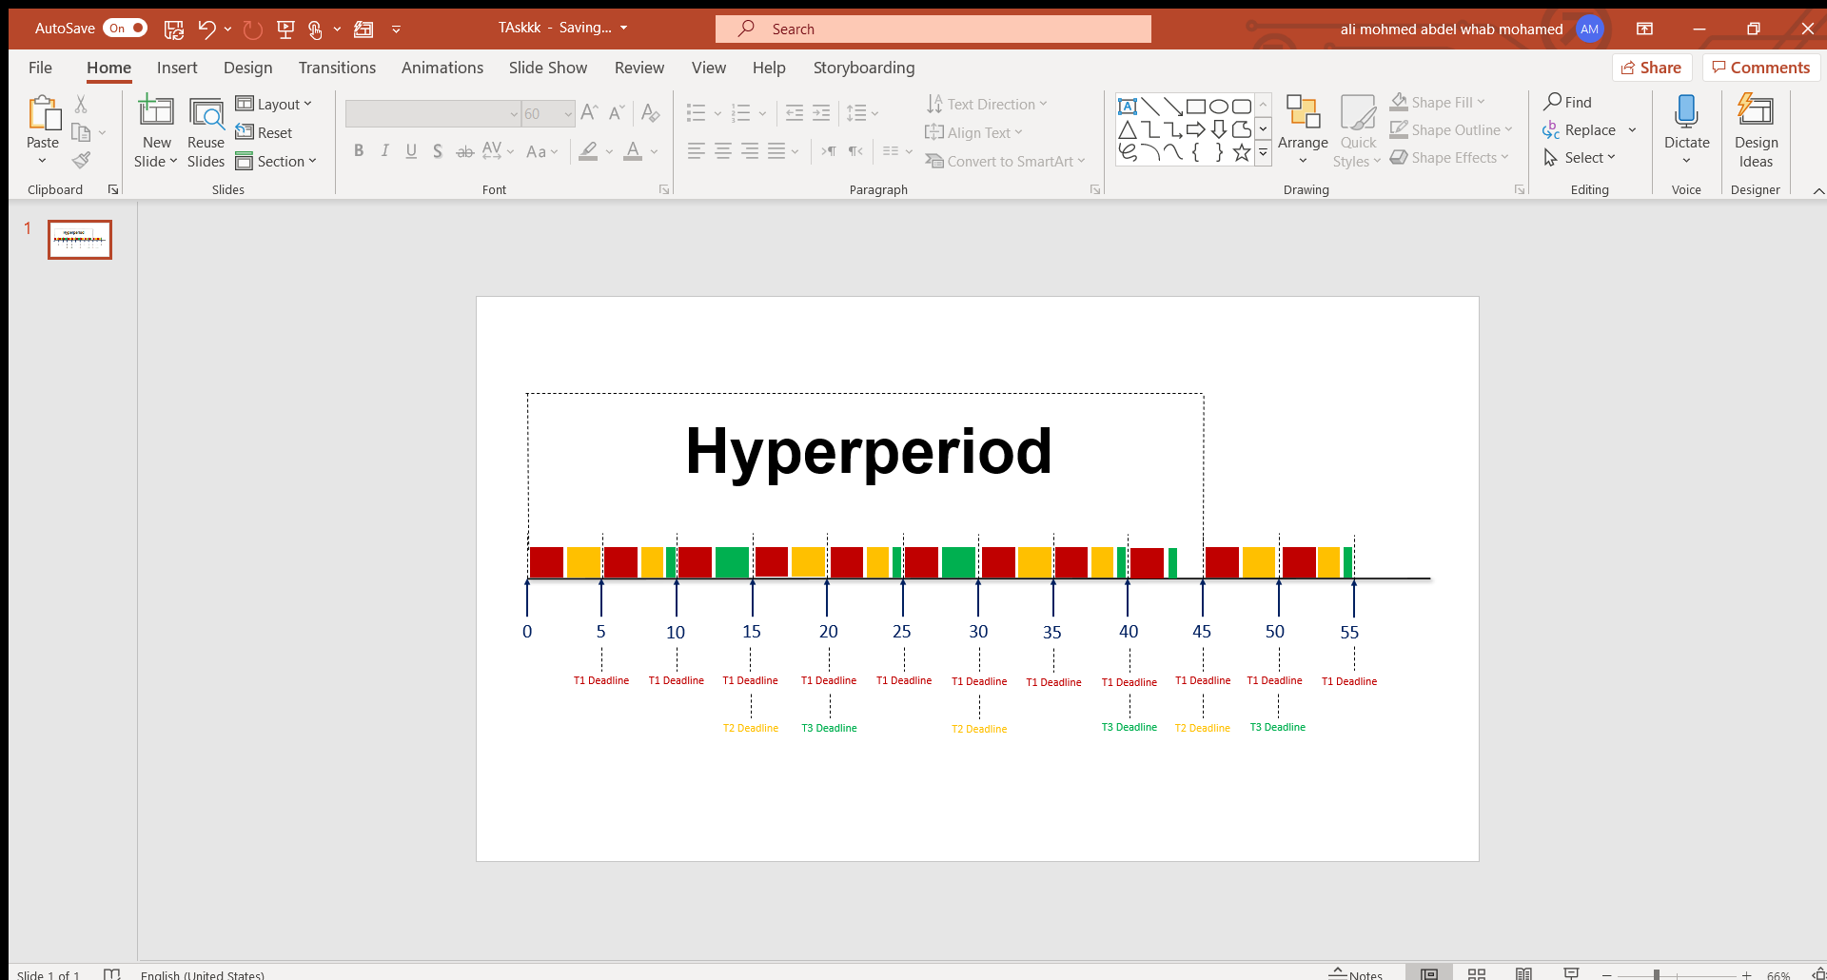

**Task 1**

**Task 2**

**Task 3**

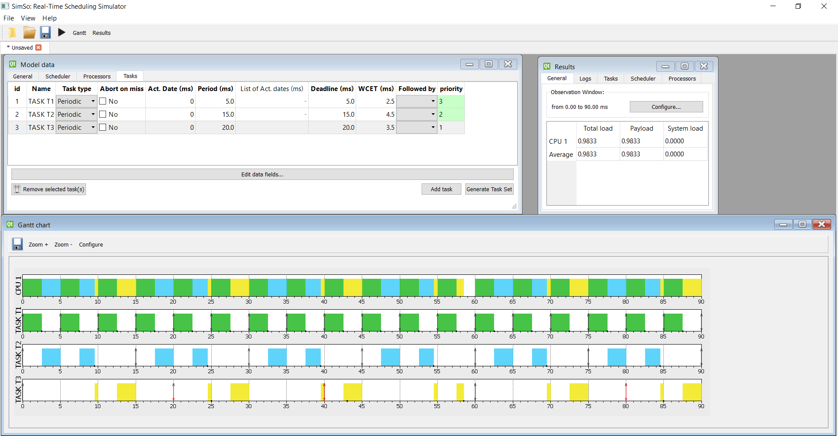As you can see Task3 miss its deadline

As you can see Task3 miss its deadline

System guaranteed not schedulable